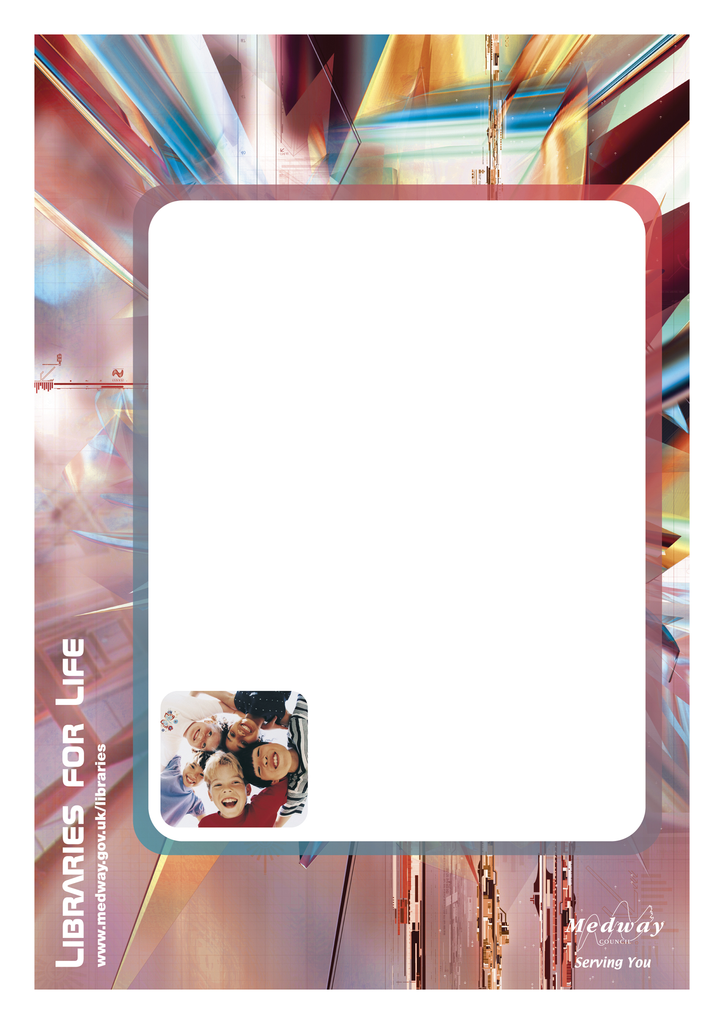
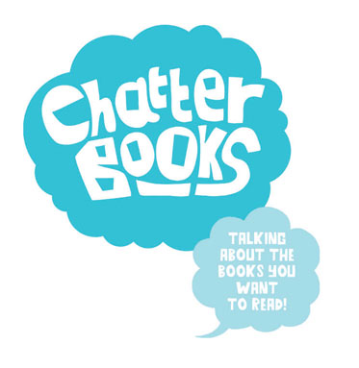

Chatterbooks

A lively reading group

for 8 – 12 year olds

Thomas Aveling School and Community Library

Wednesdays
3.45– 4.15pm
(fortnightly, term-time only)

For more information please contact Thomas Aveling School and Community Library on 01634 338728

