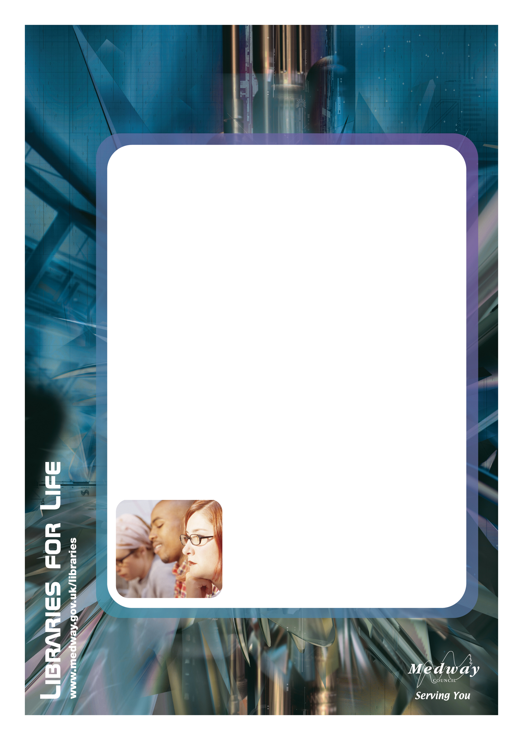

Thomas Aveling School & Community Library

We hope you will pop-into the community library when you are attending an event at the school

Come in and:
- Browse
- Use library computers and access the Internet for free
- Warm up with a cup of tea or coffee
- Meet our friendly staff
- And much more…

Opening hours:
Monday to Friday 3 - 6.00pm
Saturday 10am - 4.00pm

We look forward to welcoming you into the library

